D and F Block

Introduction to D and F Block Elements

Overview and Prerequisites
The study of D and F block elements is a highly scoring and conceptually straightforward part of Inorganic Chemistry. While the chapter is vast, much of it is an extension of the Periodic Classification of Elements.

Position in the Periodic Table
The D and F block elements are situated in specific regions of the modern periodic table based on where the differentiating (last) electron enters the subshell.
- D-Block Definition: Elements where the last electron is filled in the d-subshell of the penultimate shell.
- F-Block Definition: Elements where the last electron enters the f-subshell.

Series of Elements
The elements are categorized into specific series based on the principal quantum number of the orbital being filled.

A. D-Block Series
There are four transition series in the d-block, though their importance for JEE varies:
1. 3d Series (First Transition Series): The last electron enters the 3d orbital. This is the most important series for exams, as the majority of questions are framed from here.
2. 4d Series (Second Transition Series): The last electron enters the 4d orbital.
3. 5d Series (Third Transition Series): The last electron enters the 5d orbital.
4. 6d Series (Fourth Transition Series): This series is generally not covered in detail for the JEE syllabus.

B. F-Block Series (Inner Transition Elements)
The f-block consists of two series, each containing 14 elements:
1. Lanthanoids (4f series): Follows Lanthanum; the differentiating electron enters the 4f subshell.
2. Actinoids (5f series): Follows Actinium; the differentiating electron enters the 5f subshell.

Syllabus for F-Block
For JEE preparation, the F-block is treated as a concise topic. The specific syllabus points to master include:
- Electronic Configuration: Understanding the (n-2)f^{1-14} filling.
- Oxidation States: Identifying the stability of the +3 state and common exceptions.
- Atomic and Ionic Radii: Specifically focusing on the Lanthanoid and Actinoid Contractions.

High-Yield Revision Sheet
Must Remember:
- D-Block Groups: 3 through 12.
- F-Block Location: Two series (4f and 5f) at the bottom.
- 3d Series Priority: {high-priority}
- Last-Minute Point: The last electron entering a d-subshell defines a d-block element; however, only those with incomplete d-orbitals in ground or ion states are "transition elements" (this excludes Zn, Cd, Hg).

--------------------------------------------------------------------------------

D-Block Properties and Characteristics {part I}

I. General Electronic Configuration
The d-block elements are those in which the last electron enters the d-subshell of the penultimate shell (n-1).
- General Formula: (n-1)d^{1-10} ns^{0-2}.
- The NCERT Specification: Many textbooks use (n-1)d^{1-10} ns^{1-2} but must specify "Except Palladium" to be accurate.
- The Palladium Exception (Z=46): This is the most critical exception. Its configuration is 4d^{10} 5s^{0}. It is the only element in the d-block with zero electrons in its outer s-subshell.

Exceptional Configurations (Stability of Orbitals)
Elements often deviate from the expected filling order to achieve the extra stability associated with half-filled (d^5) or fully-filled (d^{10}) subshells.
- Chromium (Cr): [Ar] 3d^5 4s^1 (instead of 3d^4 4s^2).
- Copper (Cu): [Ar] 3d^{10} 4s^1 (instead of 3d^9 4s^2).

Mnemonic for All Exceptions:
"Nawabi kyun karein maut tak, rukawat raah mein padegi, aage pitayi aur hogi".
{ 'hogi' sirf sentence complete karne k liye h }
(Covers: Nb, Cu, Cr, Mo, Tc, Ru, Rh, Pd, Ag, Pt, Au).
{ sare exception m sirf ek electron aage peeche hota h }

II. Classification of Elements
Category | Elements | Description
Coinage Metals | Cu, Ag, Au | Historically used for minting coins.
Volatile Metals | Zn, Cd, Hg | Characterized by low melting/boiling points; Hg is liquid at room temperature.
Transition Elements | Groups 3–11 (partially) | Specifically those with incomplete d-subshells.

III. Transition Elements: Definition & Criteria
A Transition Element is defined as an element that has an incompletely filled d-orbital in its ground state OR in any one of its stable oxidation states.

- Scandium (Sc): Transition element because it is 3d^1 in the ground state.
- Copper (Cu): Transition element. Although its ground state is 3d^{10} (filled), its stable +2 oxidation state (Cu²⁺) is 3d^9 (incomplete).
- Zinc, Cadmium, Mercury (Zn, Cd, Hg): These are d-block elements but NOT transition elements. They have a d^{10} configuration in their ground state and their only stable oxidation state (+2).

- Statement: "All transition elements are d-block elements, but all d-block elements are not transition elements".

IV. Physical Properties and Metallic Structures
Transition metals are typical metals displaying the following:
- High tensile strength, ductility, and malleability.
- High thermal and electrical conductivity.
- Metallic luster (shine).

# Hardness
- Generally, transition metals are very hard (e.g., Iron).
- Exceptions: Zn, Cd, and Hg are soft metals. Mercury (Hg) is a liquid at room temperature and therefore not hard at all.

# Metallic Structures
Transition metals typically crystallize in lattices like BCC, HCP, or CCP.
- Exceptions: Zn, Cd, Hg, and Mn they show one or more typical metallic structures at normal temperatures.

V. Melting Point Trends {Imp}
Why do they have High Melting Points?
The high melting point is due to strong Metallic Bonding. In transition metals, both the outer ns unpaired electrons and the inner (n-1)d unpaired electrons participate in bonding because the energy gap between them is very small.
Factors affecting metallic bond strength :-
- Metallic bond strength is directly proportional to the number of unpaired electrons, these electrons contribute to covalent-like bonding within the metal lattice.
- Higher Z_eff means higher metallic bonding meaning higher M.P.

Trend Across the 3d Series
1. Increase: From Sc to Cr, the number of unpaired electrons increases, strengthening the bond and raising the MP.
2. The Manganese Anomaly: Mn has an exceptionally low MP despite being d^5. This is because its electrons are very stable in a half-filled configuration and participate less in metallic bonding.
3. Decrease: After Mn, electrons start pairing up (Fe to Zn), reducing the number of unpaired electrons and lowering the MP.
# In any row the melting points of these metals rise to a maximum at d^5 except for anomalous values of Mn and Tc and fall regularly as the atomic number increases. {No exception in 5d series W(Tungsten) has the highest M.P.}
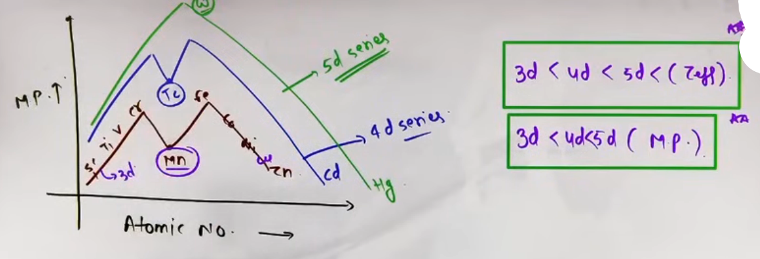
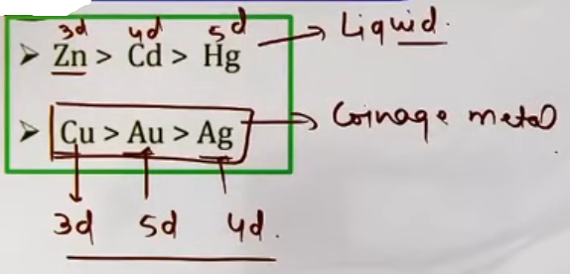# iska bhi dhyaan rakhna h ye bhi exception h
Trend Down the Group
- Order: 5d series > 4d series > 3d series.
- Reason: Effective Nuclear Charge (Z_{eff}) increases down the group in d-block, leading to stronger metal-metal (M-M) bonding.
- Key Fact: Tungsten (W) has the highest melting point in its series.
High-Yield Revision Sheet
Must Remember:
- Palladium: 4d^{10} 5s^0.
- Non-Transition d-block: Zn, Cd, Hg.
- Highest MP Element: Tungsten (W).
- Lowest MP (Liquid): Mercury (Hg).
- Copper's uniqueness: Only 3d element with a Positive Eᵒ (+0.34V).
Melting Point Summary:
- Left to Right: Increases then decreases (dip at Mn).
- Top to Bottom: 5d > 4d > 3d.
- Bonding: Both (n-1)d and ns electrons participate due to low energy gap.
- Size Trap: Zr and Hf have almost identical sizes due to Lanthanoid Contraction. Aided by poor shielding of 4f electrons.

--------------------------------------------------------------------------------

Properties of D-Block Elements {part II}

Enthalpy of Atomization (ΔHₐ)
D-block elements have high enthalpies of atomisation.
- Definition: The energy required to convert one mole of a solid metal into gaseous atoms. In metals, this is essentially the same as Sublimation Enthalpy.
M2(s) --> 2M(g)
M(s) --> M(g)
- The Bonding Connection: It is directly proportional to the strength of the Metallic Bond {OR Melting point}.
- Key Factor: Stronger metallic bonds result from a higher number of unpaired electrons.
Trend and Intuition
- Series Trend: In the 3d series, it generally increases up to the middle (where unpaired electrons are maximum) and then decreases.
- Series Comparison: The general order across series is 5d > 4d > 3d.
[ Zinc has the lowest enthalpy of atomization in the 3d series and in the whole d-block. Reason: Zinc (3d^{10} 4s^2) has zero unpaired electrons, leading to very weak metallic bonding. ]

Atomic and Ionic Radii
- 3d Series (Left to Right):
1. Decrease: From Sc to Mn (due to increasing Z_{eff}).
2. Constant: Fe to Ni (Shielding by d-electrons balances nuclear charge).
3. Increase: Cu to Zn (Electron-electron repulsions dominate).
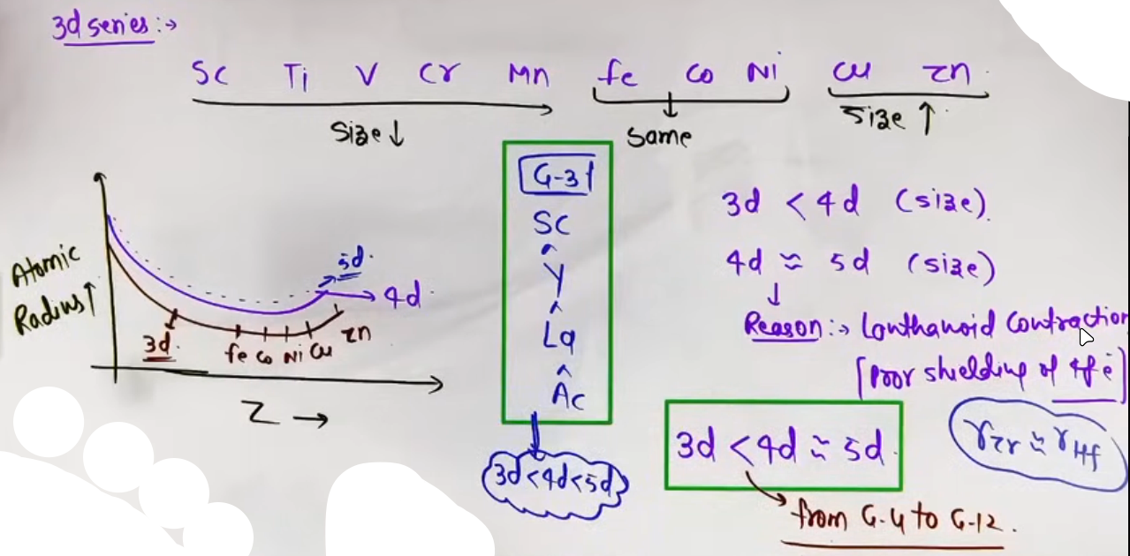
- Group Trend (Down the Group): Size increases from 3d to 4d, but 4d ≈ 5d series. Reason: Poor shielding by 4f electrons. This causes the nucleus to exert a stronger pull on outer electrons than expected. Exception: This does not affect Group 3 (Sc, Y, La), where size increases normally down the group.

Density
- Formula: Density = Mass/Volume.
- Left to Right Trend: Generally increases.
- Reason: Atomic mass increases significantly while atomic volume (radius) decreases or stays relatively constant.
# Zinc has lower density than Copper.
# Reason : Zinc’s atomic size increases abruptly, leading to a larger volume and lower density.

- 3d Series Order: Sc (Min) → Cu (Max), then a drop at Zn.

Ionization Enthalpy (IE)
- Relation to Size: Generally, IE ∝ 1/Radius.
- Group Order: For Groups 3, the order is 3d > 4d > 5d.
- Group Order: For Groups 4–12, the order is 5d > 3d > 4d.
- Reason: 5d series has high IE due to Lanthanoid contraction increasing Z_{eff}.

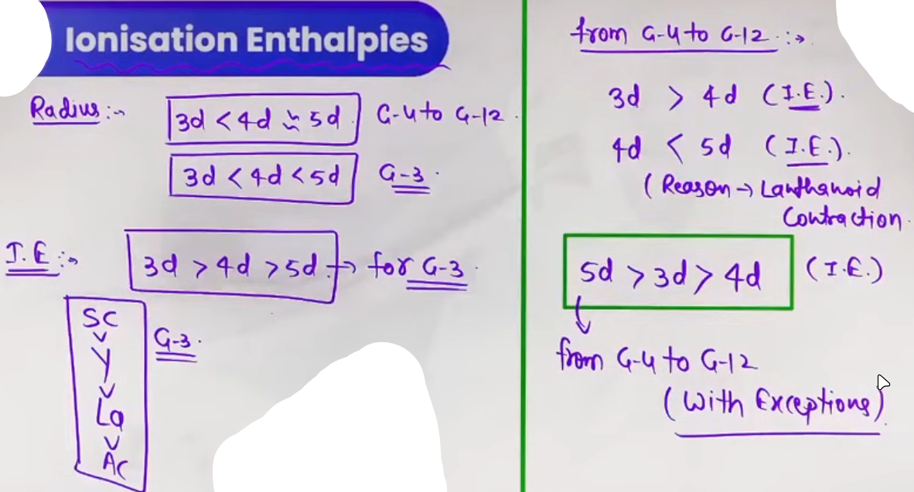
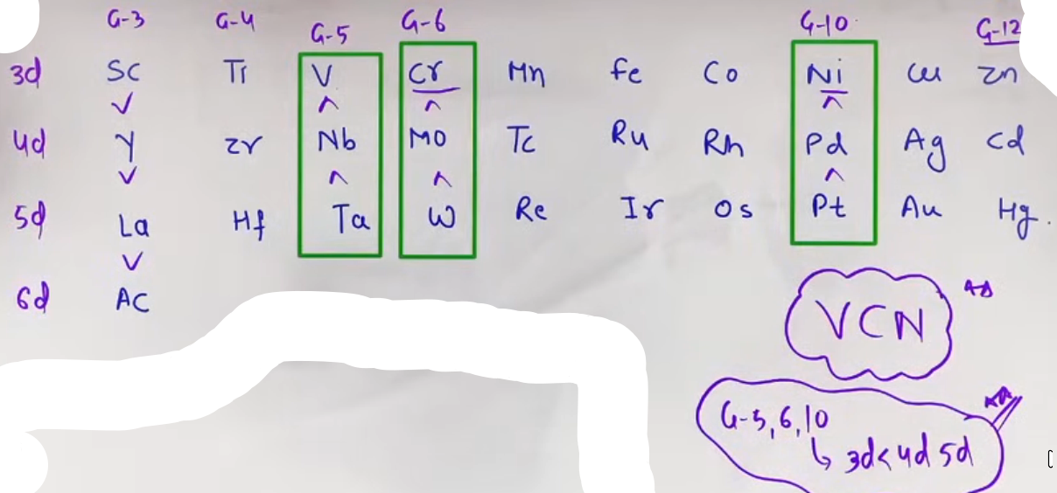
Order of ionisation enthalpies in 3d-series :-
Sc < Ti > V < Cr < Mn < Fe > Co > Ni < Cu < Zn
Advanced Intuition: Exchange Energy
- The Vanadium Anomaly: IE of Vanadium is lower than Titanium.
- Reason: Removing an electron from V (d^3) results in a d^2 configuration which then rearranges. The Exchange Energy released during transitions like d^3 → d^4 (in ions) stabilizes the system, reducing the net energy required to remove the electron.

Successive Ionization Enthalpies
- High IE₂: Cr and Cu (because Cr⁺ is 3d^5 and Cu⁺ is 3d^{10} —both are very stable).
- High IE₃: Mn and Zn (because Mn²⁺ is 3d^5 and Zn²⁺ is 3d^{10}).
- JEE Insight: Zn and Cu do not show +3 oxidation states because their IE₃ is extremely high.

Magnetic Properties
- Paramagnetic: Substances with at least one unpaired electron.
- Diamagnetic: Substances with no unpaired electrons.
- Spin-only Magnetic Moment Formula:
μ = √[n(n+2)] Bohr Magnetons (BM)
(where n = number of unpaired electrons).

Oxidation States
- Variable States: Unlike s-block, d-block elements show multiple states because the energy gap between ns and (n-1)d is very small, allowing both to participate in bonding.
- Range:
- Scandium: +3 only (most stable).
- Zinc: +2 only.
- Manganese: Shows the maximum number of states (up to +7).

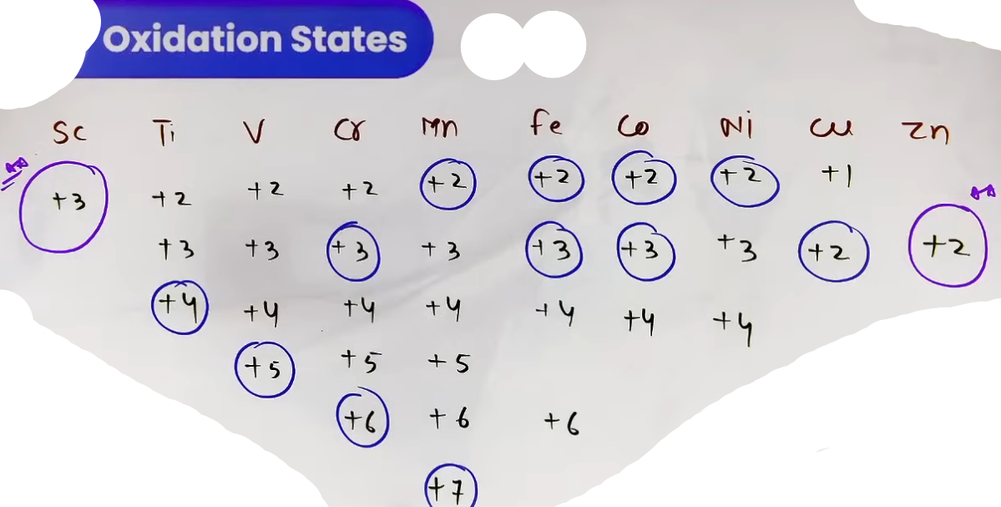# jin m gola mara h vo unki usual oxidation state h ye in oxidation states m jyadatar rehte h
# Mn shows highest oxidation state of +7 in the 3d series.
# Ru and Os have a maximum oxidation state (+8) which is highest oxidation state shown by any element.

Stability Trends (JEE Advanced Focus)
- D-Block vs. P-Block: In the d-block, higher oxidation states are more stable down the group (Opposite of the Inert Pair Effect in p-block).
Example: W⁶⁺ and Mo⁶⁺ are more stable than Cr⁶⁺. Thus, Cr⁶⁺ (in K₂Cr₂O₇) is a strong oxidizing agent, while W⁶⁺ is not.
- Stabilization: High oxidation states are stabilized by Fluorine (due to high lattice/bond energy) and Oxygen (due to its ability to form multiple bonds).
Note: Oxygen is superior to Fluorine in stabilizing the highest states (e.g., MnO₄⁻ vs. MnF₄).

High-Yield Revision Sheet
Property | Key JEE takeaway
Atomization | Zn is the lowest in 3d series (no unpaired electrons).
Atomic Radius | Zr/Hf and Nb/Ta have same size due to Lanthanoid Contraction.
Density | Copper > Zinc (Zinc's volume is too large).
IE Stability | Cr²⁺ → Cr³⁺ is easy due to half-filled t_{2g} (d^3) stability.
Oxidation State | Ru/Os show max state of +8 with Oxygen.
Hydration | Cu²⁺ (aq) is more stable than Cu⁺ (aq) because of its very high negative hydration enthalpy.

Teacher's Warning: Always check the medium for KMnO₄. In acidic medium, n=5 (Mn⁷⁺ → Mn²⁺); in neutral/weakly basic, n=3 (Mn^{+7} → MnO₂).
--------------------------------------------------------------------------------

D-Block Characteristics & Trends

I. Alloy Formation
- Alloys are homogeneous solid solutions where atoms of one metal are distributed randomly among the atoms of another metal.
- Such alloys are formed by atoms with metallic radii that are within about 15% of each other.
- The alloys so formed are hard and have often high melting points.
- Alloys of transition metals with non transition metals such as brass (copper-zinc) and bronze (copper-tin), are also of considerable industrial importance.

- D-Block Suitability: Because transition metals in the same series have very similar atomic sizes, they form alloys extensively.
- Properties: Alloys are generally harder and have higher melting points than their parent metals.

Common Examples Table
Alloy | Composition
Brass | Copper (Cu) + Zinc (Zn)
Bronze | Copper (Cu) + Tin (Sn)
Gun metal | Cu(87%) + Sn(10%) + Zn(3%)
Stainless Steel | Fe + Cr + Ni + C
German Silver | Cu(50%) + Zn(25%) + Ni(25%)
Bell metal | Cu(80%) + Sn(20%)
UK silvercoin | Cu + Ni

II. Complex Formation
Transition metals are unique in their ability to form a vast number of complex compounds (coordination compounds).

- Reasons for Formation:
1. Small Ionic Size: High charge density.
2. High Effective Nuclear Charge (Z_{eff}): Stronger attraction for ligands.
3. Presence of Vacant d-orbitals: These orbitals can accept lone pairs of electrons from ligands to form coordinate bonds.
III. Interstitial Compounds
These are formed when small atoms (H, C, N, or B) are trapped in the interstitial sites (voids) of the metal crystal lattice.

- Nature: They are typically non-stoichiometric and are neither ionic nor covalent.
- Examples: TiC, Mn₄N, Fe₃H, VH_{0.56}, and TiH_{1.7}.

Physical & Chemical Properties {isse question aate h}
Property | Characteristic
Melting Point | Very high; higher than those of pure metals.
Hardness | Extremely hard, some borides approach hardness of diamond.
Conductivity | They retain metallic conductivity.
Chemical Reactivity | They are chemically inert.

IV. Standard Electrode Potentials (Eᵒ)

# A metal with (-ve) SRP can displace H₂ from dilute acid

The Thermodynamic Cycle (M²⁺/M)
The standard electrode potential is not determined by a single factor but by the sum of three energy changes:
1. Enthalpy of Sublimation (Δ H_{sub}): M(s) → M(g) (Energy required).
2. Ionization Enthalpy (IE₁ + IE₂): M(g) → M²⁺(g) (Energy required).
3. Enthalpy of Hydration (Δ H_{hyd}): M²⁺(g) → M²⁺(aq) (Energy released).
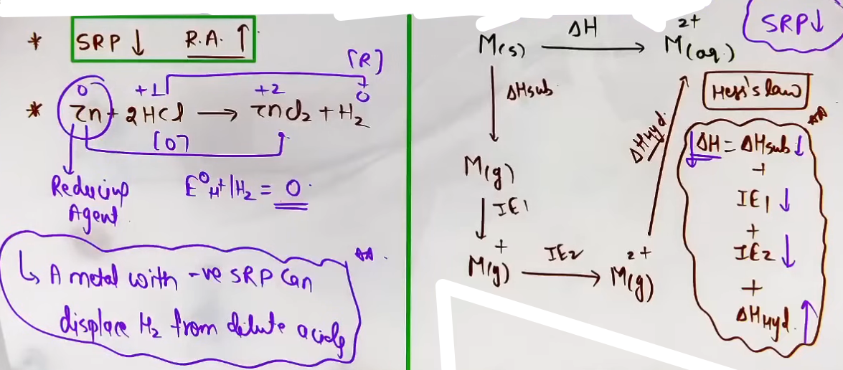

A. Trends in the 3d Series (M²⁺/M Standard Electrode Potentials)
General Trend: Eᵒ values become less negative across the series (Sc to Cu) due to the general increase in IE₁ + IE₂.
Exceptions:
- The Copper Exception: Copper is the only 3d metal with a positive Eᵒ (+0.34V).
- Reason: High energy required to transform Cu(s) to Cu²⁺(g) is not balanced by its hydration enthalpy.
- Result: Copper cannot liberate H₂ gas from dilute acids.
# Only oxidising acids (nitric and hot conc. sulphuric) react with Cu.
- Irregularities (Mn, Zn, and Ni):
- Mn and Zn: Have more negative Eᵒ than expected. This is due to the stability of the half-filled (d^5 for Mn²⁺) and fully-filled (d^{10} for Zn²⁺) configurations.
- Ni: Has a more negative Eᵒ than expected due to its exceptionally high hydration energy (smallest size in the series).
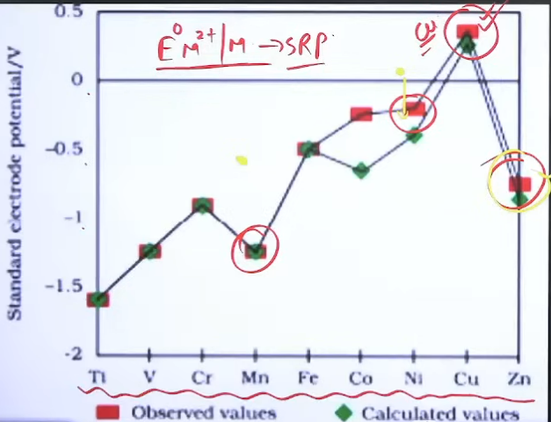
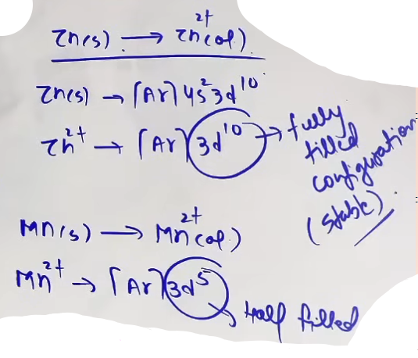
B. Trends in M³⁺/M²⁺ Potentials
This potential measures the ease of oxidizing a +2 ion to a +3 ion.
- Low Eᵒ (Easy Oxidation):
- Scandium: Very low/negative because Sc³⁺ has a stable noble gas (d^0) configuration.
- Manganese: High (+1.57V) because Mn²⁺ is already d^5 (very stable). Removing another electron is difficult.
- Iron: Lower than Mn because Fe³⁺ is d^5 (stable half-filled) while Fe²⁺ is d^6.
- High Eᵒ (Difficult Oxidation):
- Zinc: Highest value because it involves breaking a d^{10} configuration (Zn²⁺).
# The comparatively low value for Cr is related to the stability of Cu^3+ (half-filled T₂g level).
# In aqueous solution Co²⁺ is more stable and Co³⁺ is highly unstable, but Co³⁺ is highly stable in complex compounds due to high CFSE released. {High Z_eff --> High CFSE}
# Cr²⁺, V²⁺ and Ti²⁺ are good reducing agents and liberate H₂ from dilute acids. {SRP (-ve)}
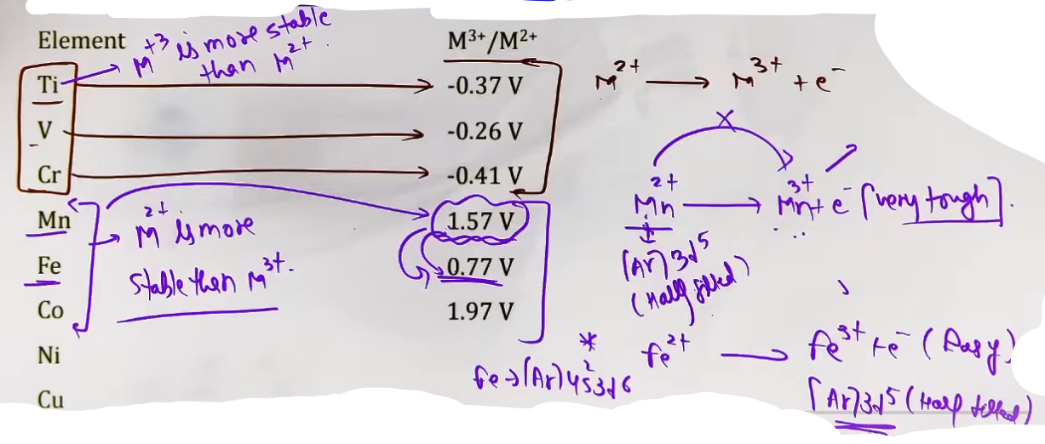
V. Catalytic Properties
Transition metals and their compounds are effective catalysts due to:
1. Variable Oxidation States: They can form unstable intermediates and change oxidation states to provide a new pathway with lower activation energy.
2. Complex Formation: Ability to provide a surface for reactants to adsorb or form complexes.
VI. Color of Ions: d-d Transitions
The Mechanism
When a ligand approaches a transition metal ion, the degenerate d-orbitals split into two sets of different energies (e.g., t_{2g} and e_g).
- d-d Transition: An electron absorbs a specific wavelength of visible light to jump from a lower energy d-orbital to a higher one.
- Observed Color: The color we see is the complementary color of the wavelength absorbed.

Colorless vs. Colored Ions
- Colorless (d^0 and d^{10}): No d-d transitions are possible if the d-orbitals are empty (Sc³⁺, Ti⁴⁺) or completely full (Zn²⁺, Cu⁺).
- The Charge Transfer Exception (LMCT): Some d^0 species are intensely colored.
- KMnO₄ (Purple) and K₂Cr₂O₇ (Orange): Color is due to Ligand-to-Metal Charge Transfer (LMCT), not d-d transitions.
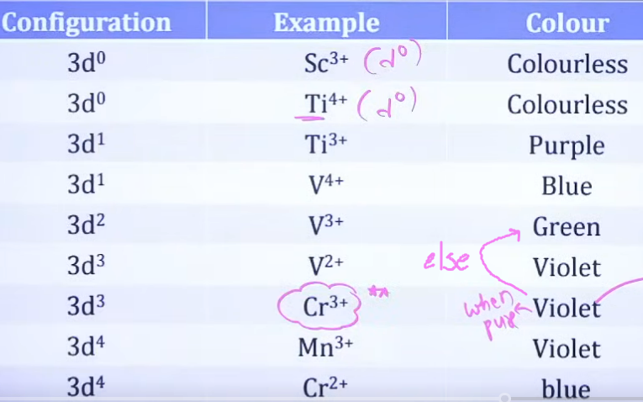
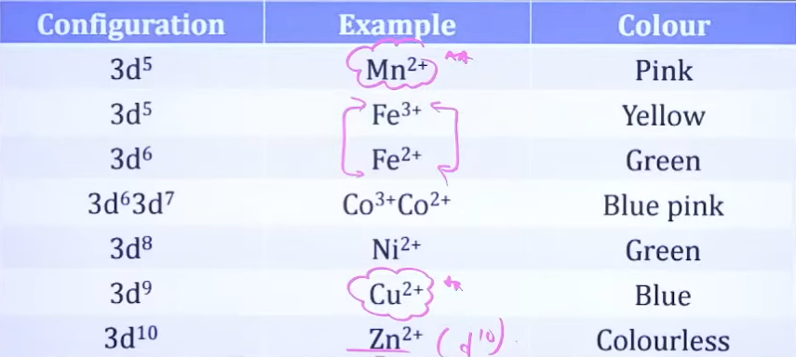
Common Mistakes and Traps
Mistake | Why Students Make It | Correct Thinking
Assuming Zn is a catalyst | They think all d-block elements are catalysts. | Only transition elements (variable oxidation states) are typically good catalysts.
Cu liberating H₂ | Students think all active metals liberate H₂. | Cu has a positive Eᵒ and cannot liberate H₂ from acids.
KMnO₄ d-d transition | It's colored, so they assume d-d transition. | Mn is d^0 in KMnO₄. Color is due to LMCT.
Interstitial = Covalent | Because they are hard like diamond. | They are non-stoichiometric and retain metallic conductivity.

High-Yield Revision Points
- Interstitial: TiC is harder than pure Ti but still conducts electricity.
- Size Rule: Zr and Hf have almost identical radii due to Lanthanoid contraction, allowing them to occur together in nature.
- Electrode Potential: The Eᵒ of Ni is more negative than expected due to its high hydration enthalpy.
- M³⁺/M²⁺ Stability: Cr²⁺ is a reducing agent because Cr³⁺ is more stable (half-filled t_{2g}). Mn³⁺ is an oxidizing agent because Mn²⁺ is more stable (d^5).
--------------------------------------------------------------------------------
# Many copper (I) compounds are unstable in aqueous solution and undergo disproportionation.
2Cu⁺ --> Cu²⁺ + Cu
# The stability of Cu²⁺(aq) rather that Cu⁺(aq) is due to the much more negative hydration enthalpy of Cu²⁺(aq) than Cu⁺(aq), which more than compensates for the second ionisation enthalpy of Cu.

## Cu⁺ more stable in gaseous form
## Cu²⁺ more stable in aqueous form

--------------------------------------------------------------------------------

Important Compounds of D-Block Elements

I. Oxides of Transition Metals
Core Theory & Chemical Reasoning {Ye classification of elements m kiya h, nature of oxides}
Transition metals form a variety of oxides where the nature (acidic/ basic/ amphoteric) depends heavily on the oxidation state of the metal.

- Low Oxidation States (+1, +2, +3): Generally Basic in nature.
- Example: CrO is basic.
- Exception: Cr₂O₃ is Amphoteric.
- Intermediate Oxidation States (+4): Generally Amphoteric.
- Example: MnO₂, V₂O₄.
- High Oxidation States (+5, +6, +7): Generally Acidic.
- Examples: V₂O₅ (+5), CrO₃ (+6), Mn₂O₇ (+7).
- These acidic oxides react with water to form oxoacids:
- Mn₂O₇ + H₂O → 2HMnO₄ (Permanganic Acid).
- CrO₃ + H₂O → H₂CrO₄ (Chromic Acid) or H₂Cr₂O₇ (Dichromic Acid).
# All the metals except scandium form MO oxides which are ionic.

---
# Pehle Amphoteric k liye check karna h phir neutral k liye aur phir aage :)

Amphoteric oxides :
Zn, Sn, Be, Al, Pb, Ga, Cd ➡ All oxides are amphoteric in nature
As³⁺,Fe³⁺,Sb³⁺,Cr³⁺,V⁵⁺,Te⁴⁺ ➡ oxides are amphoteric only in these oxidation states

Neutral oxides :
CO, NO, N2O ➡ Only these three oxides are neutral in nature

Metal oxides :
 | {Oxidation state} | {Nature}
Metals(d-block) | (+1, +2, +3) | Basic
Metals(d-block) | (+4) | Amphoteric
Metals(d-block) | (+5, +6, +7) | Acidic

Acidic oxides :
All non-metal, metalloid oxides are acidic {par pehle amphoteric check kar lena}
---

II. Potassium Permanganate (KMnO₄)
Preparation
KMnO₄ is prepared from Pyrolusite ore (MnO₂), a black-brown mineral.
Step 1 (Conversion to Manganate): MnO₂ is fused with an alkali-hydroxide (KOH or NaOH etc.) in the presence of an oxidizing agent (O₂ or KNO_3 etc.).
- MnO₂ → {KOH, O₂} K₂MnO₄ (Potassium Manganate - Green). {is equation p bhi question aaye h isko yaad karna hoga}
Step 2 (Conversion to Permanganate): The green manganate is converted to purple permanganate via:

- Disproportionation: In acidic or neutral/weakly basic medium, MnO₄²⁻ is unstable and splits into MnO₄⁻ and MnO₂. {ispe question aaya h}
3MnO₄²⁻ + 4H⁺/CO2 → 2MnO₄⁻ + MnO₂ + 2H₂O
# This KMnO₄ is not used as lab reagent because of the presence of traces of MnO₂ {MnO₂ itself is a oxidising agent} pata nahi chalega oxidation kisne kiya KmnO₄ ne ya MnO₂ ne.

- Commercial/Electrolytic Oxidation: Alkaline solution of manganate is electrolyzed; MnO₄⁻ forms at the anode.
MnO₄²⁻ [Manganate] → MnO₄⁻(Anode) [Permanganate ion] + H2(Cathode)
{electrolytic oxidation in alkaline solution}

- another method:
MnO₄²⁻ + Cl2/O3 → MnO₄⁻ + KCl/O2

- Lab Method: Mn²⁺ salts react with Peroxodisulphate (S₂O₈²⁻) to give MnO₄⁻.
2Mn²⁺ + 5S₂O₈²⁻ + 8H₂O → 2MnO₄⁻ + 10SO₄²⁻ + 16H⁺
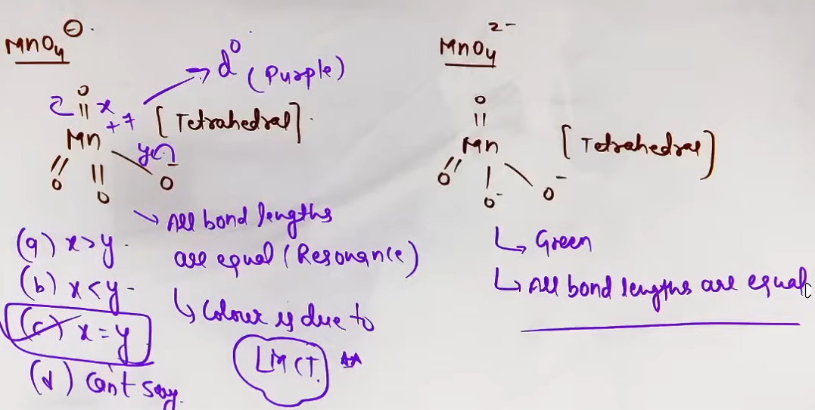
Structure and Physical Properties
Property | Permanganate Ion (MnO₄⁻) | Manganate Ion (MnO₄²⁻)
Color | Purple (LMCT) | Green (d-d transition)
Geometry | Tetrahedral | Tetrahedral
Oxidation State | +7 (d^0) | +6 (d^1)
Magnetic Nature | Diamagnetic | Paramagnetic (1 unpaired e^-)
Bonding | All Mn-O bond lengths are equal due to resonance. | All Mn-O bond lengths are equal due to resonance.

Chemical Properties & Reactions
- Thermal Decomposition: {Imp}
2KMnO₄ →{Δ} K₂MnO₄ + MnO₂ + O₂
This is a standard method to prepare oxygen gas.

- Reaction with H₂SO₄: Cold concentrated H₂SO₄ reacts to form Mn₂O₇, which is explosive. {not a redox rxn}
KMnO₄ + H₂SO₄ --> Mn₂O₇ + KHSO₄ + H₂O
# It is unstable in sunlight so it is kept in dark coloured bottles.
# eqn same as thermal decomposition

# question aaya h isme -
- Oxidizing Action: KMnO₄ acts as a powerful oxidizing agent in all mediums {best in acidic than neutral than basic}:
- Acidic: MnO₄⁻ → Mn²⁺ (n-factor = 5).
- Neutral/Weakly Basic: MnO₄⁻ → MnO₂ (n-factor = 3).
- Strongly Basic: MnO₄⁻ → MnO₄²⁻ (n-factor = 1).

Qs: In neutral or faintly alkaline medium, KMnO₄ being a powerful oxidant can oxidise, thiosulphate almost quantitatively, to sulphate. In this reaction overall change in oxidation state of manganese will be - {Ans 3}

Rxn with hydrogen peroxide: {question aaya h ispe}
2MnO₄⁻ + 6H⁺ + 5H₂O₂ → 2Mn²⁺ + 5O₂ + 8H₂O

- Rxn with conc. HCl
KMnO₄ + conc. HCl --> MnCl₂ + Cl₂ + H₂O
KMnO₄ oxidises HCl
While using KMnO₄ as oxidision agent in volumetric analysis{titration}, conc. HCl is not used to make solution acidic as it is oxidised to Cl₂. Conc. H₂SO₄ is used instead.
{KMnO₄ HCl ko nipta deta h toh vo acidic medium bana hi nahi pata isliye uski jagah H₂SO₄ use karte h #viva ka favourite sawal}
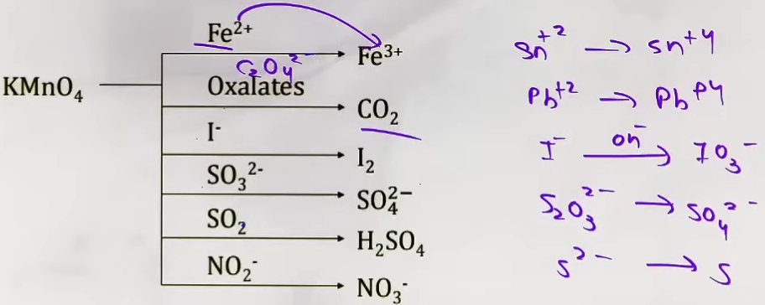
- Manganous salt is oxidised to MnO₂; the presence of zinc sulphate or zinc oxide catalyses the oxidation : [NCERT ki eqn h]
2MnO₄⁻ + 3Mn²⁺ 2H₂O --> 5MnO₂ + 4H⁺

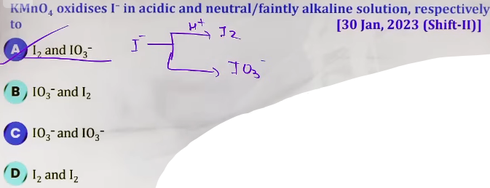aise question aate h ki agar yaad h toh kar loge nahi toh nahi honge logic wale h hi nahi
III. Potassium Dichromate (K₂Cr₂O₇)
Preparation
Prepared from Chromite ore (FeCr₂O₄).
1. Step 1:
4FeCr₂O₄ + 8Na₂CO₃ + 7O₂ → 8Na₂CrO₄ + 2Fe₂O₃ + 8CO₂
(Yellow, Sodium Chromate).
2. Step 2: 2Na₂CrO₄ →{H⁺} Na₂Cr₂O₇ (Orange, Sodium Dichromate).
3. Step 3: Na₂Cr₂O₇ + 2KCl → K₂Cr₂O₇ + 2NaCl. Potassium dichromate is less soluble and crystallizes out.
----
CrO₄²⁻ (yellow) chromate ion
Cr₂O₇²⁻ (orange) dichromate ion
----
Intuition: Why use Potassium instead of Sodium?
Na₂Cr₂O₇ is used in organic reactions but not in redox titrations, in redox titrations K₂Cr₂O₇ is used as a Primary Standard because Na₂Cr₂O₇ is hygroscopic (absorbs water from the air), which changes its concentration and makes it unreliable for precise volumetric analysis.

Equilibrium & Structure
- pH Dependency: Chromate and Dichromate ions are interconvertible depending on pH.
CrO₄²⁻ becomes Cr₂O₇²⁻ in acidic medium
2CrO₄²⁻ + 2H⁺ --> Cr₂O₇²⁻ + H₂O
Cr₂O₇²⁻ becomes CrO₄²⁻ in basic medium
Cr₂O₇²⁻ + 2OH⁻ --> 2CrO₄²⁻ + H₂O
# Therefore K₂Cr₂O₇ behaves as oxidising agent only in acidic medium because in basic medium it converts into chromate not dichromate.
- Dichromate Structure: Two tetrahedra share one corner (Cr-O-Cr link). The Cr-O-Cr bond angle is slightly larger than 109ᵒ (=126ᵒ)due to repulsion between the large chromate groups.
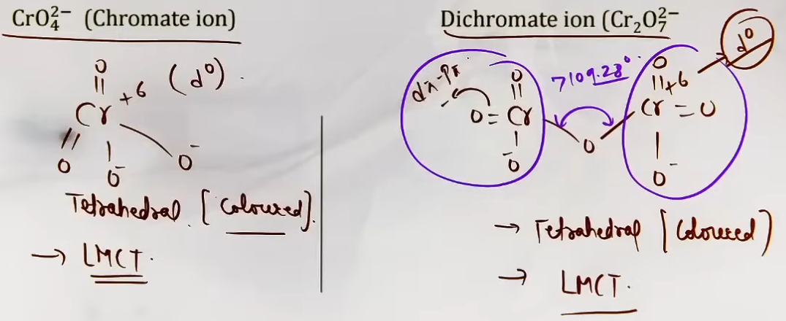

Standard Reactions
- Oxidizing Action: Acts as an oxidizing agent only in acidic medium (n-factor = 6).
Fe²⁺ → Fe³⁺
I⁻ → I₂
Sn²⁺ → Sn⁺⁴;
H₂S²⁻ → S
SO3²⁻ → SO₄²⁻
S₂O3²⁻ → SO₄²⁻
C₂O4²⁻ → CO₂
2MnO₄⁻ + 16H⁺ + 5C₂O₄²⁻ →2Mn²⁺ + 8H₂O + 10CO₂
Pb²⁺ → Pb⁺⁴.

- Chromyl Chloride Test:
When a mixture of metal chloride is heated with K₂Cr₂O₇ and conc. H₂SO₄ acid, orange red fumes/vapour of chromyl chloride are formed.
K₂Cr₂O₇ + NaCl + 6H₂SO₄ --> 2KHSO₄ + 2CrO₂Cl₂ + 3H₂O.
This is used to detect Chloride ions. {question aayah is reaction par, yaad karna h}

- Reaction with H₂O₂: Reaction with H₂O₂ in acidic medium produces CrO₅, which has a Butterfly Structure and two peroxy links (Cr is in +6 state).
Cr₂O₇²⁻ + H₂O₂ + 2H⁺ --> 2CrO₅ + 5H₂O
(Deep blue colour, butterfly structure)

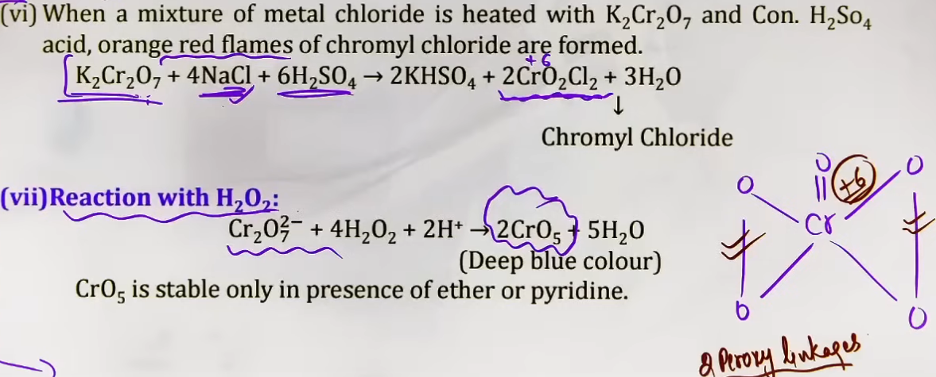
- Heating: {ispe question puche h}
4K₂Cr₂O₇ →{Δ} 4K₂CrO₄ + 2Cr₂O₃ +3O₂
(Potassium chromate) (Chromic oxide)

IV. Problem-Solving Framework
Question Type | Identification Clues | Strategy / Shortcut
Color Change | Orange to Yellow or vice-versa. | Check pH. Orange = Acidic (Cr₂O₇²⁻); Yellow = Basic (CrO₄²⁻).
Titration Medium | Why not use HCl for KMnO₄? | KMnO₄ oxidizes HCl to Cl₂ gas, interfering with results. Use H₂SO₄ instead.
Oxidation Products | I⁻ reaction with KMnO₄. | Acidic → I₂. Neutral/Weakly Basic → IO₃⁻.
Magnetic Property | Manganate vs. Permanganate. | MnO₄⁻ is d^0 (Dia); MnO₄²⁻ is d^1 (Para).

V. Common Mistakes and Traps
Mistake | Why Students Make It | Correct Approach / Thinking
d-d Transition for Color | KMnO₄ and K₂Cr₂O₇ are colored. | They are d^0. Color is due to LMCT (Charge Transfer).
CrO₅ Oxidation State | Butterfly structure looks like +10. | Calculating through bonds shows Cr is +6. There are 4 oxygen atoms in peroxy links (-1) and one oxo oxygen (-2).

VI. High-Yield Revision Sheet
Must Remember
- KMnO₄ heating: Produces green K₂MnO₄ and O₂.
- K₂Cr₂O₇ heating: Produces yellow K₂CrO₄, Cr₂O₃, and O₂.
- Hygroscopic nature: Na₂Cr₂O₇ is hygroscopic; K₂Cr₂O₇ is not (Primary Standard).
- Oxide Trend: Acidity increases with oxidation state.
Frequently Tested Patterns
- The Iodide Trap: I⁻ goes to I₂ in acid but IO₃⁻ in neutral/base with KMnO₄.
- Chromyl Chloride: Red-orange vapors of CrO₂Cl₂ prove the presence of Cl⁻.
- Manganate Stability: MnO₄²⁻ is only stable in strong alkaline medium.

--------------------------------------------------------------------------------

F-Block Elements (Inner Transition Elements)

I. Core Theory: Introduction to F-Block
Definition & Placement
- Inner Transition Elements: Elements in which the differentiating (last) electron enters the (n-2)f orbital.
- Position: Two series of 14 elements each, placed separately at the bottom of the periodic table.
- Lanthanoids (4f series): Cerium (Z=58) to Lutetium (Z=71).
- Actinoids (5f series): Thorium (Z=90) to Lawrencium (Z=103).
- The Transition Link: Although Lanthanum (Z=57) and Actinium (Z=89) are d-block elements, they are studied with the f-block because their properties are nearly identical to Lanthanoids and Actinoids, respectively.

General Electronic Configuration
- General Formula: (n-2)f^{1-14} (n-1)d^{0-1} ns^2.
- Lanthanoids (4f): [Xe] 4f^{1-14} 5d^{0-1} 6s^2.
- Actinoids (5f): [Rn] 5f^{1-14} 6d^{0-1} 7s^2.
----
general symbol of lanthanoides - Ln
general symbol of actinoides - Ac
----

II. Lanthanoids (4f Series)
1. Electronic Configuration & Mnemonic
Elements often show anomalies in filling 5d and 4f to gain stability from half-filled or full-filled shells.
- Mnemonic for Series: Cene Par Nadiya Prem ki Samai, Eu (Yuh) Gad-Gad Tab Dil Hua, Aur Tum Ab Lauto.
- Anomalies to Note:
- Cerium (Ce, Z=58): [Xe] 4f^1 5d^1 6s^2 (Electron enters 5d before 4f is full).
- Gadolinium (Gd, Z=64): [Xe] 4f^7 5d^1 6s^2 (Maintains f^7 stability).
- Lutetium (Lu, Z=71): [Xe] 4f^{14} 5d^1 6s^2.

2. Lanthanoid Contraction
- Concept: A steady decrease in atomic and ionic radii across the series from La to Lu.
- Cause: Poor Shielding of 4f electrons. As nuclear charge increases, the 4f electrons fail to shield the outer electrons effectively, causing the nucleus to pull the outer shell closer.
- Impact on Size: This contraction is so significant that it makes the sizes of the 4d and 5d series (e.g., Zr and Hf) nearly identical.
- Atomic Size Exception: Europium (Eu) has the largest atomic radius in the series because it uses only two electrons for metallic bonding (maintaining a stable 4f^7 core).
- Ionic Size(+3): No exception. Size decreases from left to right in the series

3. Oxidation States
- Primary State: +3 is the most stable and dominant oxidation state for all Lanthanoids.
- Other States (+2 and +4): Showed by elements that can achieve f^0, f^7, or f^{14} configurations.
- Ce^{4+}: Stable due to f^0 (Noble gas) configuration. It acts as a strong oxidizing agent because it wants to return to the +3 state.
- Eu²⁺: Stable due to 4f^7. It acts as a reducing agent to reach the +3 state.
- Yb²⁺: Stable due to 4f^{14}.

4. Physical & Chemical Properties
- Appearance: Silvery-white, soft metals that tarnish rapidly in air.
- Hardness: The hardness increases with increasing atomic no.
- They have typical metallic structure and are good conductors of heat and electricity.
# Their melting points range between 1000K to 1200K but samarium(Sm, Z=62) melts at 1623K.
- Density and other properties change smoothly except for Eu and Yb.
- Color: Many trivalent ions (Ln³⁺) are colored due to f-f transitions.
- Colorless Ions: La³⁺ (f^0) and Lu³⁺ (f^{14}).
- Magnetic nature: The lanthonoid ions other than the f^0 type (La^3+ and Ce^4+) and the f^14 type (Yb²⁺ and Lu^3+) are all paramagnetic.
- Basicity of Hydroxides: La(OH)₃ is the most basic, while Lu(OH)₃ is the least basic. This is because size decreases across the series, increasing covalent character (Fajans' Rule).
@ photo – lanthanoids.png # generally gets to +3 state
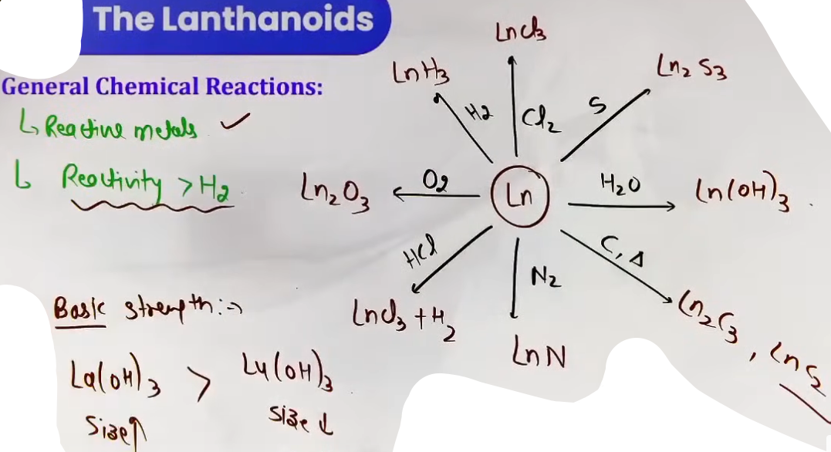
5. Uses
- The best single use of the lanthanoids is for the production of alloy steels for plates and pipes.
- A well known alloy is "mischmetall" which consists of a lanthanoid metal (~95%) and iron (~5%) and traces of S, C, Ca and Al. A good deal of mischmetall is used in Mg-based alloy to produce bullets, shell and lighter flint.
- Mixed oxides of lanthanoids are employed as catalysts in petroleum cracking.
- Some individual Ln oxides are used as phosphors in television screens and similar fluorescing surfaces.

III. Actinoids (5f Series)
1. General Characteristics
- Radioactivity: All Actinoids are radioactive.
- Trans-uranium Elements: Elements after Uranium (Z=92) are man-made and called trans-uranium elements.
- Along period size decreases.

2. Oxidation States (JEE Advanced Focus)
- Actinoids show a greater range of oxidation states (up to +7) compared to Lanthanoids.
- Reason: The energy gap between the 5f, 6d, and 7s orbitals is very small, allowing more electrons to participate in bond formation.
# Np and Pu show maximum number of oxidation states starting from +3 to +7 all oxidation states. {ispe question aaya h JEE Main 2019 (09 Apr Shift 2)}
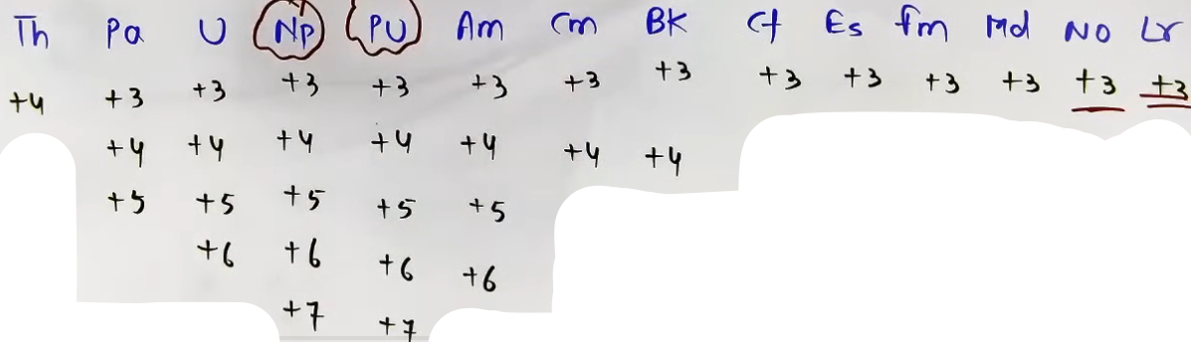

3. Actinoid Contraction (along with lanthanoid contraction)
- Comparison: Actinoid contraction is greater than Lanthanoid contraction.
- Reason: 5f electrons provide even poorer shielding than 4f electrons because they are more diffused and further from the nucleus.

IV. Comparative Summary: Lanthanoids vs. Actinoids
Feature | Lanthanoids (4f) | Actinoids (5f)
Max Oxidation State | +4 | +7 (due to small energy gaps)
Complex Formation | Less tendency | Greater tendency
Radioactivity | Only Promethium (Pm, Z=61) | All are radioactive
Energy Gap | Larger gap (4f-5d) | Very small gap (5f-6d-7s)

---
General Characteristics :-
# Silvery in appearance.
# Reactive metals.
# The action of boiling water on them gives a mixture of oxide and hydride and combination with most non metals takes place at moderate temperetures.
# HCl attacks all metals but most are slightly affected by nitric acid owing to the formation of protective oxide layers.
# Alkalies have no action.
# Radioactive in nature.

High-Yield Revision Sheet
Must-Remember Concepts
- Chemical Reactivity: Lanthanoids (Ln) react with:
- Acids → Liberate H₂ gas.
- Halogens → LnX_3.
- Nitrogen + Heat → LnN (Nitride).
- Sulphur + Heat → Ln_2S_3.
- Mischmetall: An alloy consisting of Lanthanoid metal (~95%), Iron (~5%), and traces of S, C, Ca, and Al. Used in magnesium-based alloys for making bullets and shells.

Problem-Solving Strategy
Question Type | Identification | Strategy
Oxidizing/Reducing Agent | Identifying Ce^{4+} or Eu²⁺. | Stability drives them to the +3 state. Ce^{4+} → Ce³⁺ (Oxidant); Eu²⁺ → Eu³⁺ (Reductant).
Basicity Comparison | Comparing Ln(OH)_3 series. | Size ∝ Basicity. Largest ion (La³⁺) is most basic; smallest (Lu³⁺) is least basic.
Magnetic Nature | f^0 and f^{14} ions. | These are diamagnetic. All other f^1 to f^{13} ions are paramagnetic.

--------------------------------------------------------------------------------

- The element that usually does NOT show variable oxidation states is:
The element which shows only one oxidation state other than its elemental form is :
Ans Sc {ek do baar aaya h}
- Interstitial compounds ki properties p question aaye h {easy}
- Alloys pe kafi question aaye h, composition pe, sare yaad karne honge
- Cu ka electrode potential, pe ek do question aaye h
- Catalysts pe question aaye h unke naam par
-- Which of the following is Lindlar catalyst?
- d-block m higher oxidation state ki stability down the group barti h ( Cr(VI) > Mo(VI) {Stability})
-- Given below are two statements :
Statement I : CrO3 is a stronger oxidizing agent than MoO3
Statement II : Cr(VI) is more stable than Mo(VI)
In the light of the above statements, choose thecorrect answer from the options given below
Ans: Statement I is true but Statement II is false
- oxidation number aur spin-only magnetic moment nikalne par question aaye h {easy}
- ions k colors pe question {easy, seedha yaad karke batane wale h} {d^0, d^10 aur f^0, f^14} {LMCT} {Fe4[Fe(CN)6]3, prussian blue precipitate}
- lanthanoids hamesha +3 oxidation state p aane ka prayas karte h {oxidation reduction power wale question p kaam aata}
-- Cerium (IV) has a noble gas configuration. Which of the following is correct statement about it?
A) It will prefer to gain electron and act as an oxidizing agent
B) It will prefer to give away an electron and behave as reducing agent
C) It will not prefer to undergo redox reactions.
D) It acts as both, oxidizing and reducing agent.
Ans: (A)
-- Which one amongst the following are good oxidising agents?
(a) Sm2+
(b) Ce2+
(c) Ce4+
(d) Tb4+
Choose the most appropriate answer from the options given below :
Ans: C and D only
- KMnO₄ alag-alag medium (acidic, neutral & basic) me alag alag tarah se reduce hota h
- lanthanoids ka dia-para hona {f^0, f^14}
- lanthanoids ka electronic configuration {easy par yaad karne padenge aur series bhi yaad karni hogi}
- The highest oxidation states of an element is generally satisfied with oxygen.
The highest manganese fluoride is MnF4, where the oxidation state of Mn is +4.
The highest manganese oxide is Mn₂O₇, where the oxidation state of Mn is +7.
-- Consider |x| is the difference in oxidation states of Mn in highest manganese fluoride and highest manganese oxide. The ions with |x| number of unpaired electrons from the following are:
A. Sc3+
B. Zn2+
C. V2+
D. Fe2+
E. Co2+
Choose the correct answer from the options given below:
Ans: C and E only
- Consider the following statements about manganate and permanganate ions. Identify the correct statements.
A. The geometry of both manganate and permanganate ions is tetrahedral.
B. The oxidation states of Mn in manganate and permanganate are +7 and +6, respectively.
C. Oxidation of Mn (II) salt by peroxodisulphate gives manganate ion as the final product.
D. Manganate ion is paramagnetic and permanganate ions is diamagnetic.
E. Acidified permanganate ion reduces oxalate, nitrite and iodide ions.
Choose the correct answer from the options given below :
Ans: A and D Only
- Mn ki first ionisation enthalpy jyada hoti h Cr se aur second enthalpy Cu ki jyada hoti h Mn
- d-block k kuch elements ka exceptional electronic configuration hota h {4: Cr, Cu}, {5: Nb, Mo, Ru, Rh, Pd, Ag}, {6: Pt Au}
- Zn then Cr --> low enthalpy of atomisation
- KMnO₄ oxidises I^- in acidic and neutral/faintly alkaline solution, respectively to
Ans: I2 and IO−3

